**INFO2222 Report**  
  
Group name: CC08_Team7  
Name: Fox Barancewicz, Wilson Husen

Summary  
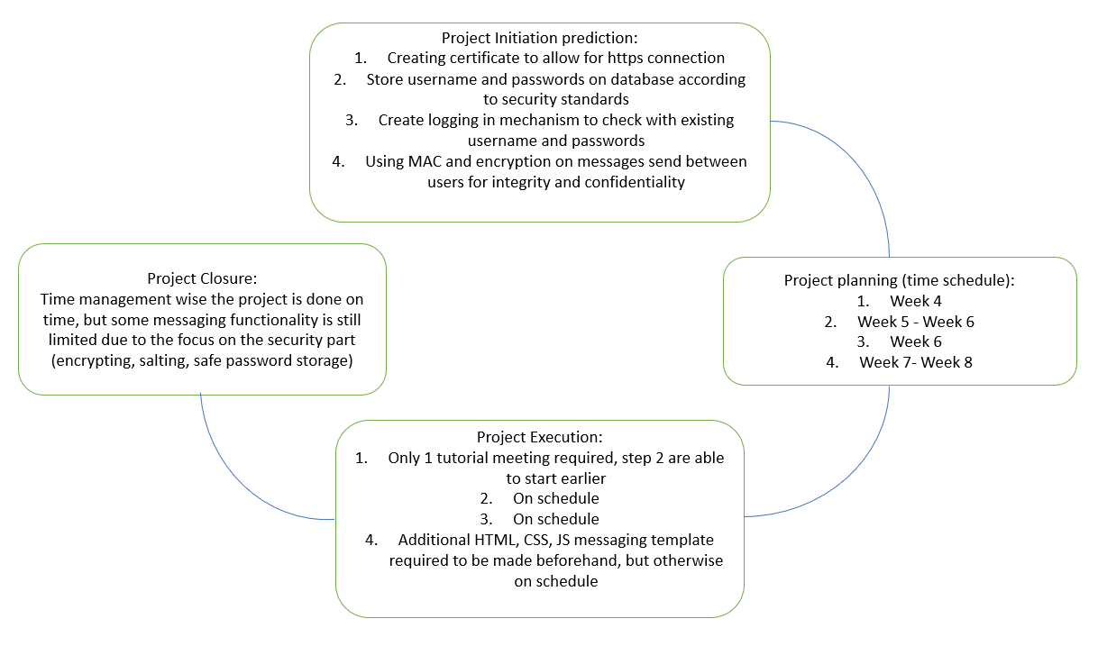

1. Username, password (encrypted with salt value) and randomly generated salt value, implemented by running password_storage.py and then storing it in storage.csv
2. Certificates are created manually with the certificate named as Assignment 1 and cert file located at /certificates/localhost.crt, used gunicorn as the server for integrating https to the website
3. Same certificate in (2) allows password to be stored securely through https.
4. Username and Password is checked for correctness when logging in by hashing the password and looping through the database to check if there is any match.
5. (Come back to this after done with message sending protocols)

Member Contribution percentage:

Tasks are mainly discussed and done together through git, refining the code progressively after each implementation of a function.

Fox: 50%

Wilson: 50%

WILL CONTINUE THE REST TOMORROW INCLUDING SCREENSHOTS ETC